Assignment 17.1

Write a program that accepts the job id as argument and returns a custom counter and a system counter (total records input to the map tasks) associated with that job.

I ran the job using custom counters as shown below.

From History server User Interface:

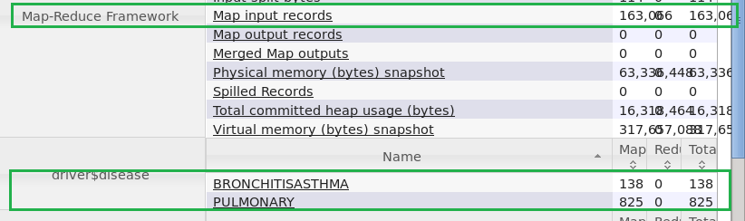

From Terminal:

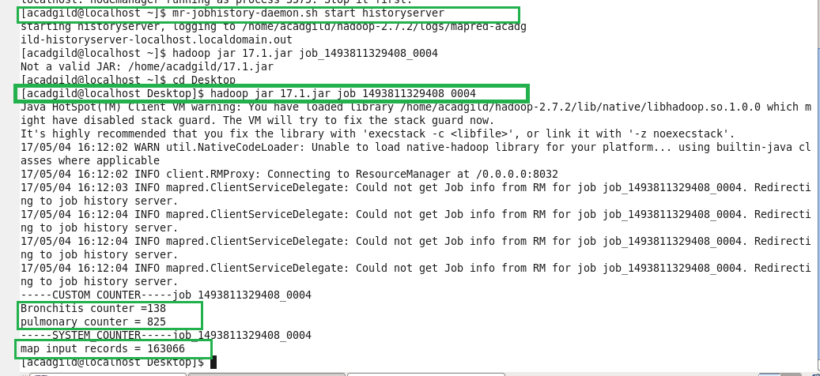

We can see from the output that for the job id 1493811329408_0004 there is 138 **Bronchitis** counter and 825 **Pulmonary** counter for 163066 map input records.

Findcounter class:

The code below is used to display the custom counter and system counter for the corresponding job id 1493811329408_0004

